WebHook via Zapier:

SVIX is integrated with zapier.
Zapier has webhook integration which gives UI support to manage the app and api calls.
We can catch the webhook request and also polls the event via zapier.

1. Using Catch Hook we can post our events to webhook.

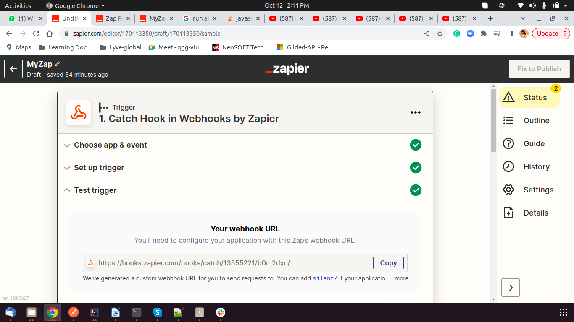

We can send our notifications to webhook url from our microservice by using the webhook url.
Like below:

request.setRow(java.util.UUID.randomUUID().toString());
request.setDate(new Date().toString());
try {
ResponseEntity<Events> eventResponse=restTemplate.postForEntity("https://hooks.zapier.com/hooks/catch/13555221/b0m2dxc/", request, Events.class);
}

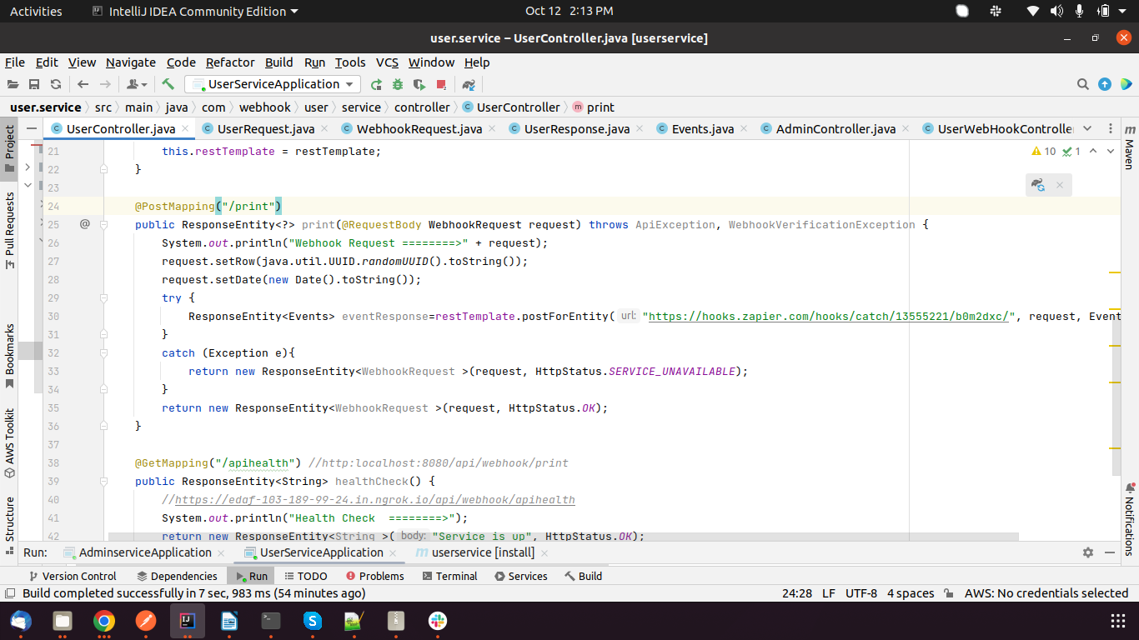
i

2. Also we can call Third party apis with GET,PUT,POST methods also from zapier webhook which provides asynchronization.

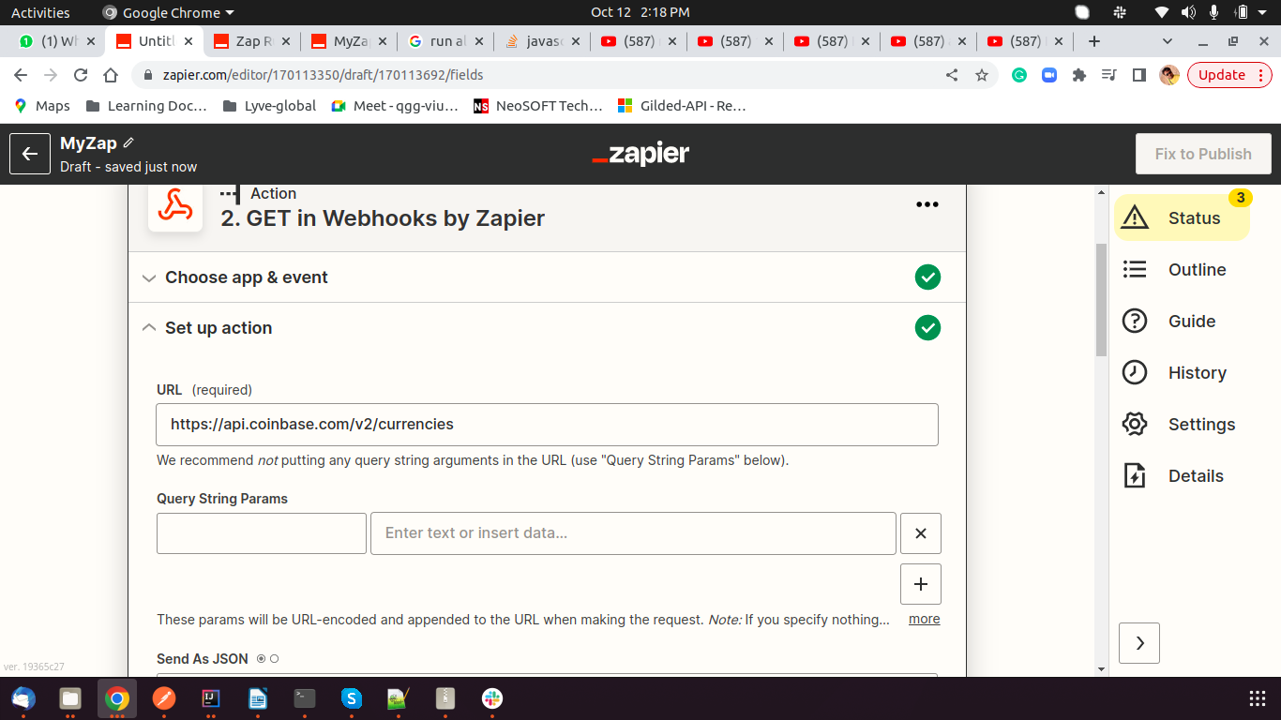

3. We can write custom api call as well by writing code in javascript or python. Using that you can fetch data from any api.

